Manav Rachna University

Computer science & Technology
CSE 4-C

SOFTWARE ENGINEERING
Lab File

(VEHICLE MANAGEMENT SYSTEM)

Submitted by: Submitted to:

SYED DANISH ALI – 2K18CSUN01043 SHREYA MAM

AMANPREET SINGH – 2K18CSUN01008

S.No | Lab No. | Description | Signature
1 | Lab 1 | Identify Problem statement
2 | Lab 2 | E-R Diagram
3 | Lab 3 | Use Case Diagram
4 | Lab 4 | Context Diagram/DFD Level 0
5 | Lab 5 | DFD Level 1
6 | Lab 6 | Class Diagram
7 | Lab 7 | Activity Diagram
8 | Lab 8 | Sequence Diagram

INDEX

LAB-1-PROBLEAM – STATEMENT:-

[2K18CSUN01043 , 2K18CSUN01008]

VEHICLE SHOWROOM MANAGEMENT SYSTEM VB PROJECTS

Vehicle showroom Management System Project .provides solution for showrooms for organizing data using software application. This software application helps administrator to update data in step by step process while selling vehicle to customer. Using this system management team can update customers information, vehicle information, payment details, Insurance details, take orders..etc.
Vehicle showroom software is presently used in every car, bike showrooms for computerizing entire system. This software package includes inventory management module, daily management details, image uploads, sales reports. There is no other scripting or server end management for this system.

VEHICLE SHOWROOM MANAGEMENT SYSTEM
System Working Process:
Initially deals will buy vehicles Form Company and update details.
• On Customer request dealers will send sales order to customer.
• Customer places order by conforming request
• Dealer will create service order
• Billing procedure is carried out.
Project Forms:
New Vehicle Request: In this form admin can update new vehicle purchase details which are requested by customer.
Purchase Request Order: This form is useful to update details of new orders with customer details and time of delivery.
Registering Form: After new vehicle is purchased details of registration, vehicle identification number, insurance details are updated.
Search Form: Using this form manager can search for customer requested vehicle availability in their show room or other show rooms.
Billing Form: This form will contain purchase details and payment details. Admin will print details from this form.
PROBLEMS WITH EXISTING SYSTEM
• Lack of security of data.
• More man power.
• Time consuming.
• Consumes large volume of pare work.
• Needs manual calculations.
• No direct role for the higher officials.
• Damage of machines due to lack of attention.
To avoid all these limitations and make the working more accurately the system needs to be computerized.
PROPOSED SYSTEM
The aim of proposed system is to develop a system of improved facilities. The proposed system can overcome all the limitations of the existing system. The system provides proper security and reduces the manual work.
ADVANTAGES OF THE PROPOSED SYSTEM
The system is very simple in design and to implement. The system requires very low system resources and the system will work in almost all configurations. It has got following features
• Security of data.
• Ensure data accuracy’s.
• Proper control of the higher officials.
• Reduce the damages of the machines.
• Minimize manual data entry.
• Minimum time needed for the various processing.
• Greater efficiency.
• Better service.
• User friendliness and interactive.
• Minimum time required.
SYSTEM SPECIFICATION
HARDWARE REQUIREMENTS
Processor : X86 Compatible processor with 1.7 GHz Clock speed
RAM : 512 MB or more
Hard disk : 20 GB or more
Monitor : VGA/SVGA
Keyboard : 104 Keys
Mouse : 2 buttons/ 3 buttons
SOFTWARE REQUIREMENTS
Operating System : Windows 2000/XP
Front end : Visual Basic 6.0
Back end : MS Access

****************************************************************************************************************************************************************************************************************************************************************************************************************************************************

LAB 3 – USE CASE DIAGRAM :- STARUML

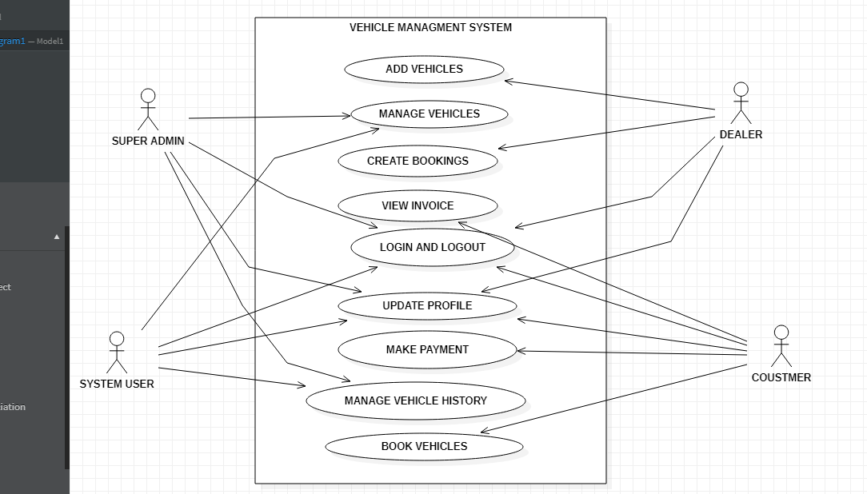

What is an use case diagram. Explain?
.
A use case diagram is a dynamic or behavior diagram in UML. Use case diagrams model the functionality of a system using actors and use cases. Use cases are a set of actions, services, and functions that the system needs to perform. In this context, a "system" is something being developed or operated, such as a web site. The "actors" are people or entities operating under defined roles within the system

LAB 7 -ACTIVITY DIAGRAM :- STAR UML

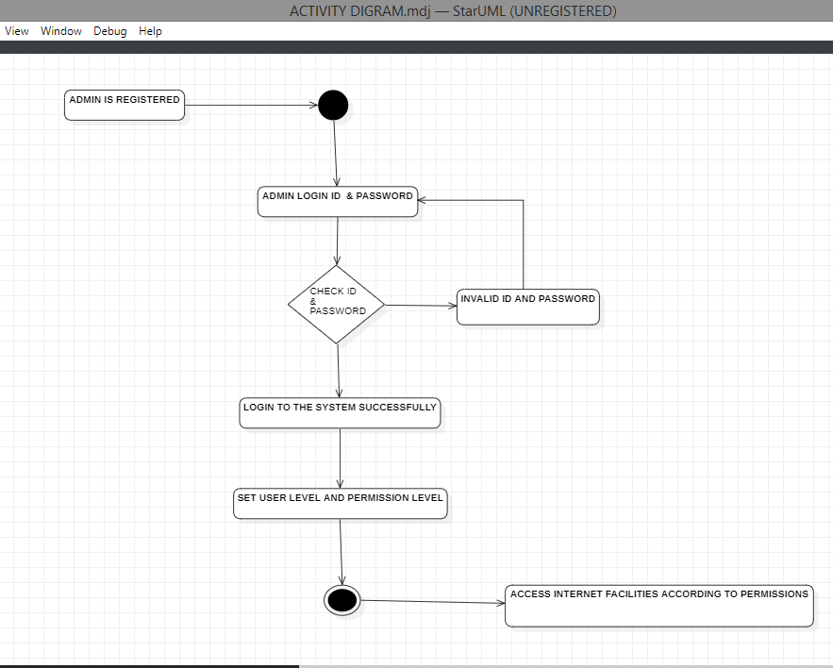

What is a activity diagram. Explain.?

Activity diagram is another important diagram in UML to describe the dynamic aspects of the system.
Activity diagram is basically a flowchart to represent the flow from one activity to another activity. The activity can be described as an operation of the system.
The control flow is drawn from one operation to another. This flow can be sequential, branched, or concurrent. Activity diagrams deal with all type of flow control by using different elements such as fork, join, etc

LAB 4 :- DFD LEVEL0 – ONLINE UML EDITOR.

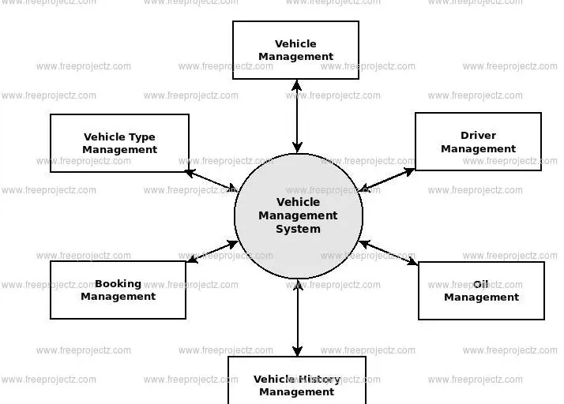
LAB 5:- DFD LEVEL1- ONLINE UML EDITOR.

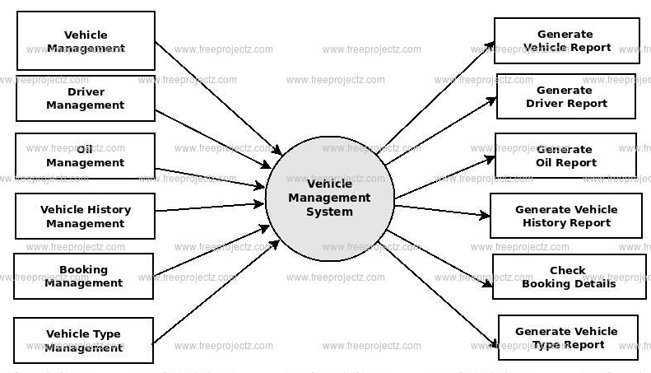

1.Explain DFD and Context Diagram?

A data flow diagram (DFD) maps out the flow of information for any process or system. It uses defined symbols like rectangles, circles and arrows, plus short text labels, to show data inputs, outputs, storage points and the routes between each destination. Data flowcharts can range from simple, even hand-drawn process overviews, to in-depth, multi-level DFDs that dig progressively deeper into how the data is handled. They can be used to analyze an existing system or model a new one

Lab 6-CLASS DIAGRAM: STARUML
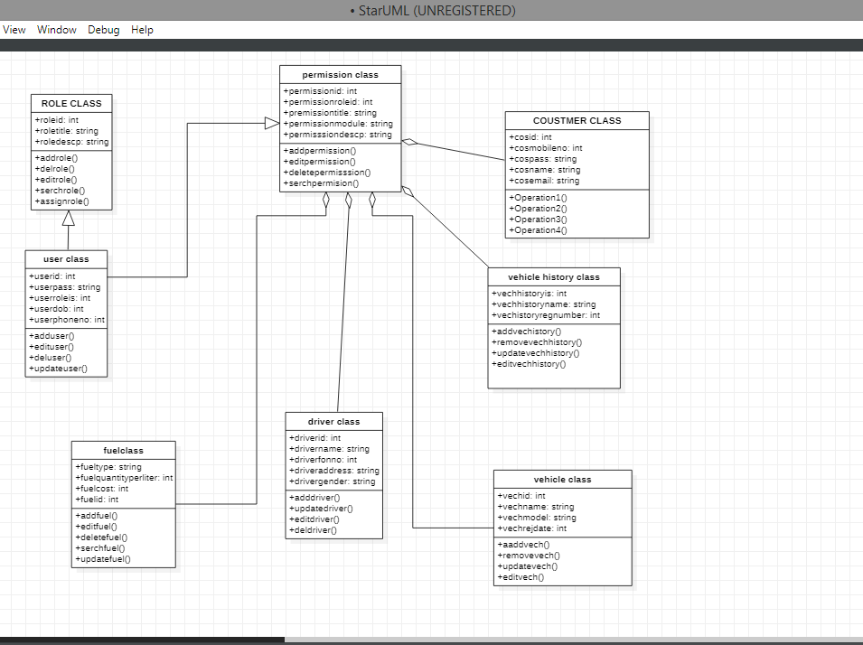

What is a class diagram explain ?

In software engineering, a class diagram in the Unified Modeling Language (UML) is a type of static structure diagram that describes the structure of a system by showing the system's classes, their attributes, operations (or methods), and the relationships among objects.

A UML class diagram is made up of: A set of classes and
A set of relationships between classes

LAB 8: SEQUENTIAL DIAGRAM-STARUML.
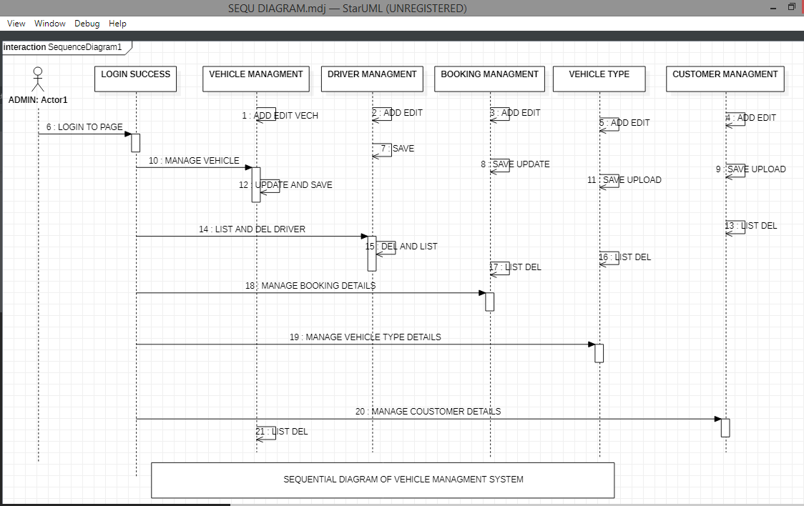

- What is a Sequence diagram. Explain.

Sequence diagrams describe interactions among classes in terms of an exchange of messages over time. They're also called event diagrams. A sequence diagram is a good way to visualize and validate various runtime scenarios. These can help to predict how a system will behave and to discover responsibilities a class may need to have in the process of modeling a new system

2.Show the notations for sequence diagram.

Basic sequence diagram notations are:

- Class Roles or Participants
Class roles describe the way an object will behave in context. Use the UML object symbol to illustrate class roles, but don't list object attributes.

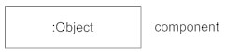

- Activation or Execution Occurrence
Activation boxes represent the time an object needs to complete a task. When an object is busy executing a process or waiting for a reply message, use a thin gray rectangle placed vertically on its lifeline.
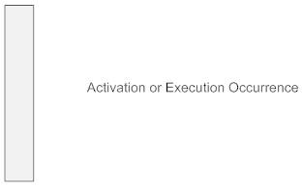

- Messages
Messages are arrows that represent communication between objects. Use half-arrowed lines to represent asynchronous messages. Asynchronous messages are sent from an object that will not wait for a response from the receiver before continuing its tasks. For message types, see below.
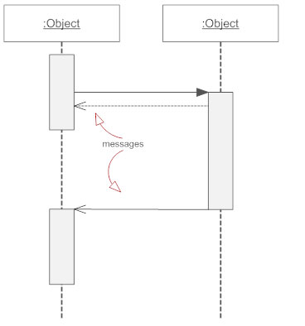

- Lifelines
Lifelines are vertical dashed lines that indicate the object's presence over time.

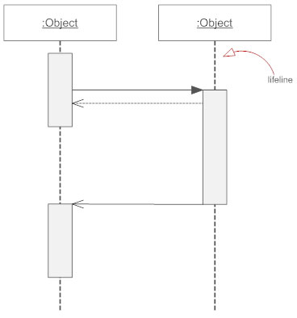

- Destroying Objects
Objects can be terminated early using an arrow labeled "<< destroy >>" that points to an X. This object is removed from memory. When that object's lifeline ends, you can place an X at the end of its lifeline to denote a destruction occurrence.

- Loops
A repetition or loop within a sequence diagram is depicted as a rectangle. Place the condition for exiting the loop at the bottom left corner in square brackets [ ].

Lab 2: ER DIAGRAM: ONLINE EDITOR-

- What is an E-R Diagram. Explain.

An entity relationship diagram (ERD) shows the relationships of entity sets stored in a database. An entity in this context is an object, a component of data. An entity set is a collection of similar entities. These entities can have attributes that define its properties.
By defining the entities, their attributes, and showing the relationships between them, an ER diagram illustrates the logical structure of databases.ER diagrams are used to sketch out the design of a database.

